CSCE-312 Quiz 7 [20 points]

**csce-312 | DUE: tuesday Nov 29, 2016 11:59pm on e-campus**

**NAME: Matthew Stevens UIN**: 924000693

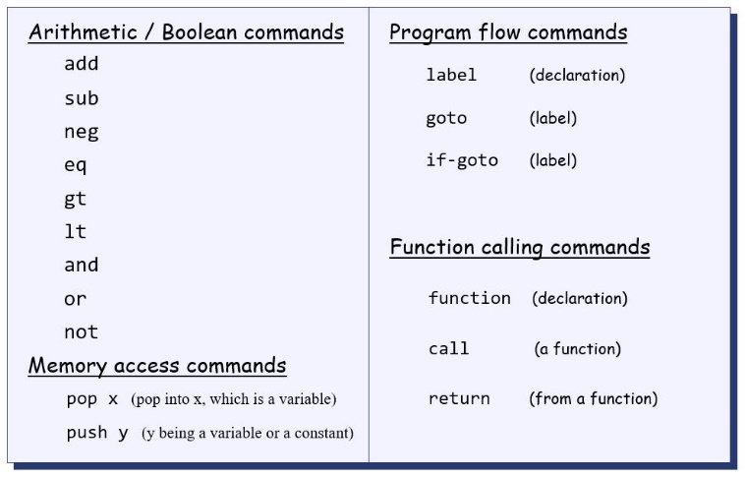

**Question 1. [3 points] Write pseudo VM code for the expression z = x+y using stack arithmetic. You may assume x, y, z are stored in consecutive memory locations. Pseudo VM code follows VM syntax as shown above but does not list specific memory segments like static, temp, argument, etc.**

**push x**

**push y**

**add**

**pop z**

**Question 2. [4 points] For the picture below, draw the final picture of the stack and static segments after execution of the following command sequence:**

**push static 3  
 push static 0  
 add  
 pop static 1**

**Stack**  **Static**

|  |  |  |
| --- | --- | --- |
| **121** |  | **5** |
| **5** |  | **-527** |
| **17** |  | **3** |
| **Stack pointer** |  | **-532** |

**Question 3. [5 points] Write pseudo VM code (stack arithmetic, memory, control, and functions) for the following high-level code. Assume that divide rounds down to an integer (for e.g. 8/3 returns 2). In your VM code you will need to write divide and multiply functions and call them from the main program.**

**if (~ (a = 0))   
 x = b/c  
else  
 x = b*c**

**//MULT function**

**function mult 2**

**push constant 0**

**pop local 0**

**push argument 1**

**pop local 1**

**label loop**

**push local 1**

**push constant 0**

**eq**

**if-goto end**

**push local 0**

**push argument 0**

**add**

**pop local 0**

**push local 1**

**push constant 1**

**sub**

**pop local 1**

**goto loop**

**label end**

**push local 0**

**return**

**//DIVIDE FUNCTION**

**function div 2**

**push constant 0**

**pop local 0**

**push argument 1**

**pop local 1**

**label loop**

**push local 1**

**push constant 0**

**eq**

**if-goto end**

**push local 0**

**push argument 0**

**sub**

**pop local 0**

**push local 1**

**push constant 1**

**sub**

**pop local 1**

**goto loop**

**label end**

**push local 0**

**return**

**push a**

**push 0**

**eq**

**not**

**if-goto divide**

**push b**

**push c**

**mult**

**goto end**

**(divide)**

**push b**

**push c**

**div**

**(end)**

**pop xHere is a reference for HACK assembly language syntax that we practiced in this course. All details are given below for references and then the questions follow.**

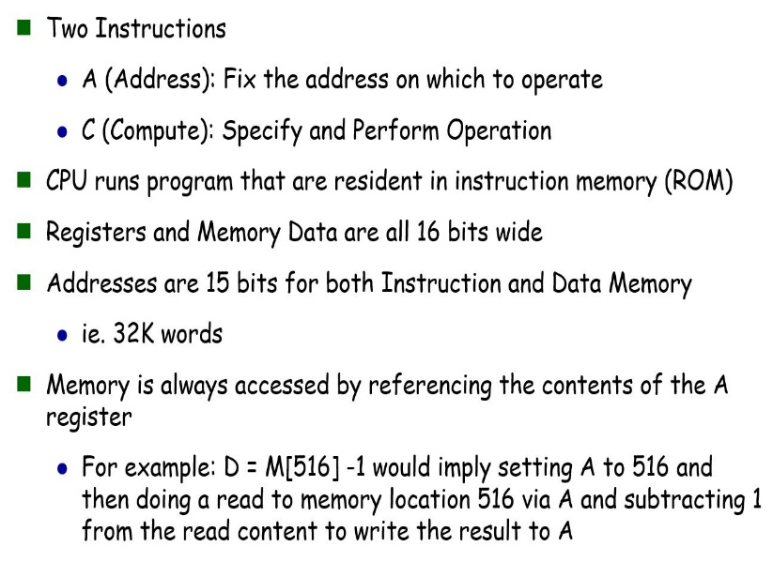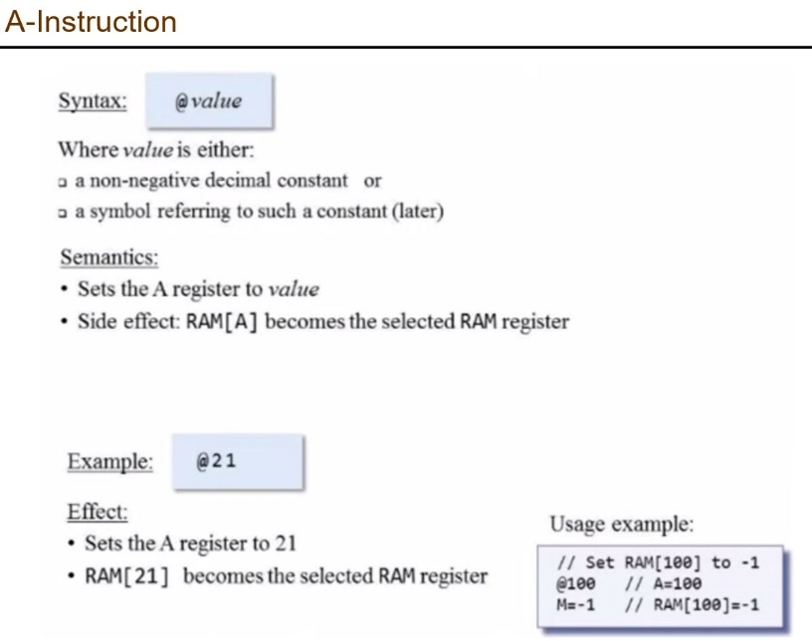

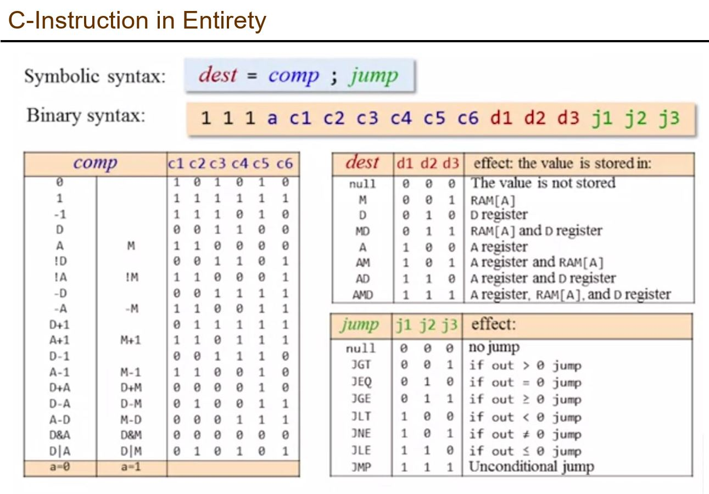

**Question 4. [8 points] Write HACK assembly code for the following VM commands:**

* **push constant 5**
* **sub**
* **pop local 2**
* **if-goto label (assume label is at ROM location 58)**

**//push constant 5:**

**@5**

**//A = 5;**

**D = A;**

**@sp**

**A = M;**

**M = D;**

**@sp**

**M = M + 1;**

**//sub**

**@sp**

**AM = M-1;**

**D = M;**

**A = A-1;**

**D = M – D;**

**//pop local 2**

**@sp**

**A = M - 1;**

**M = D;**

**A = A – 1;**

**D = A;**

**M = M – 1;**

**@sp**

**//if-goto label**

**@SP**

**AM = M – 1**

**D = M**

**@58**

**D;JNE**